eDCU Life Time Tester
Operation User Manual
Document ID: 23-10-051-VTI-CCAIC-UM
Rev.: 2.0
Safran Data Systems Pvt Ltd
 | Name | Signature | Date
Prepared By | Ananth A
Reviewed By | Prabhakar T J
Approval By | Midhunseelan O S

Customer
 | Name | Signature | Date
Reviewed By
Approved By

Document ID | 23-10-051-VTI-CCAIC-UM
Document Name: | Operation User Manual
Document No.: | R/PP-03/25
Project/Product Name: | eDCU Life Time Tester
Project/Product Code: | 23-10-051-VTI-CCAIC
Revision Status: | 2.0

Change Summary

Release No. | Date | Changed By | Change Description
Version 1.0 | 18-11-2024 | Ananth A | Initial Version

Table of Contents
Change Summary 2
1.1 Desktop Panel 4
1.2 Main Screen:: 5
1.3 Main Login: 6
1.4 Main Login Exit 7
1.5 Auto Mode: 8
1.6 Test stand Login: 9
1.7 Sequence Selection: 10
1.8 Test Windows: 11
1.9 Socket Entry Windows: 12
1.10 UUT Info Entry Windows: 13
1.11 UUT Info Entry Scroll Windows: 14
1.12 Test Selection Windows: 15
1.13 Schema File Location: 16
1.14 Schema Selection Windows: 17
1.15 Start the Chamber and Test Start Windows: 18
1.16 Running Windows of Monitor: 19
1.17 Terminate Test Procedure: 20
1.18 Error Pop-UP Test Procedure: 21
1.19 Exit Application: 22

Desktop Panel
By clicking the “Application” button in the main screen. below shown User window will appear.
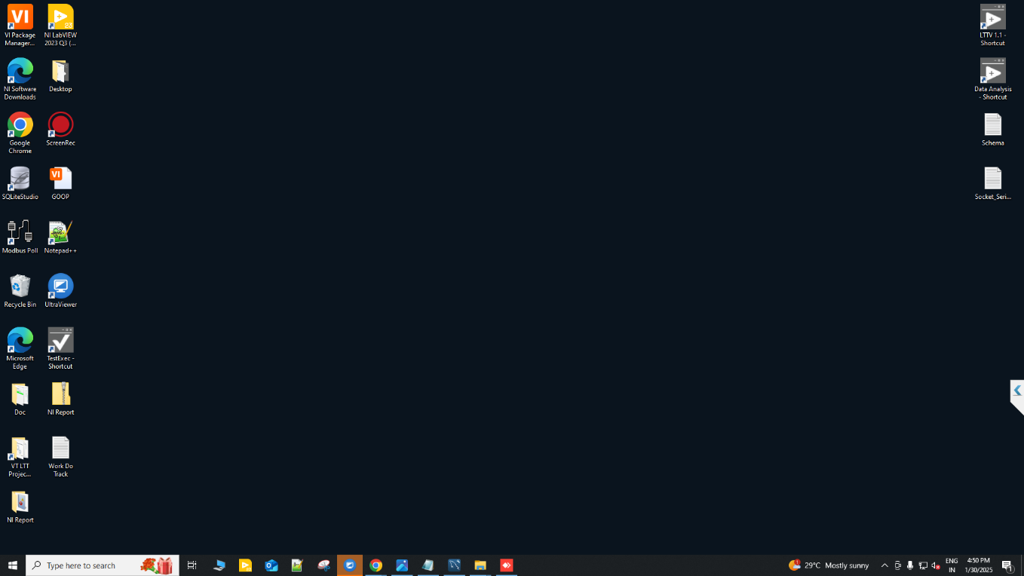
Click on Data Analyser “Application RUN AS Administrator” button.
Click on LTT “Application RUN AS Administrator” button.
Check “Schema” For Continuous Test
Check “Serial Number” For eDCU
Figure 1: Desktop Panel
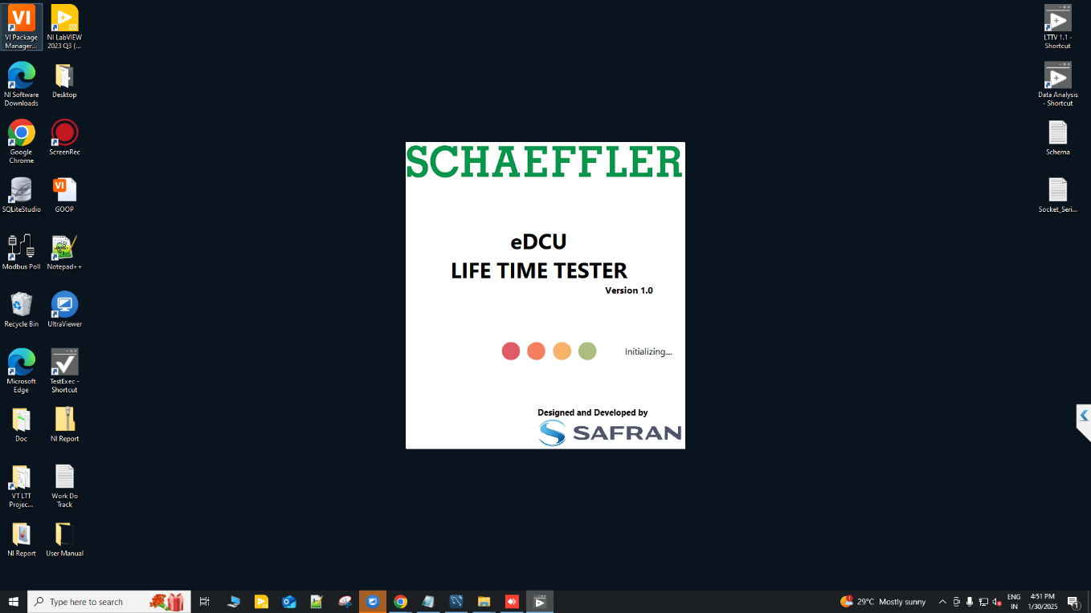
Figure 2: Loading Application

Main Screen::
Clicking the “Login” Button from the main screen below the user screen will appear. Click “OK”.
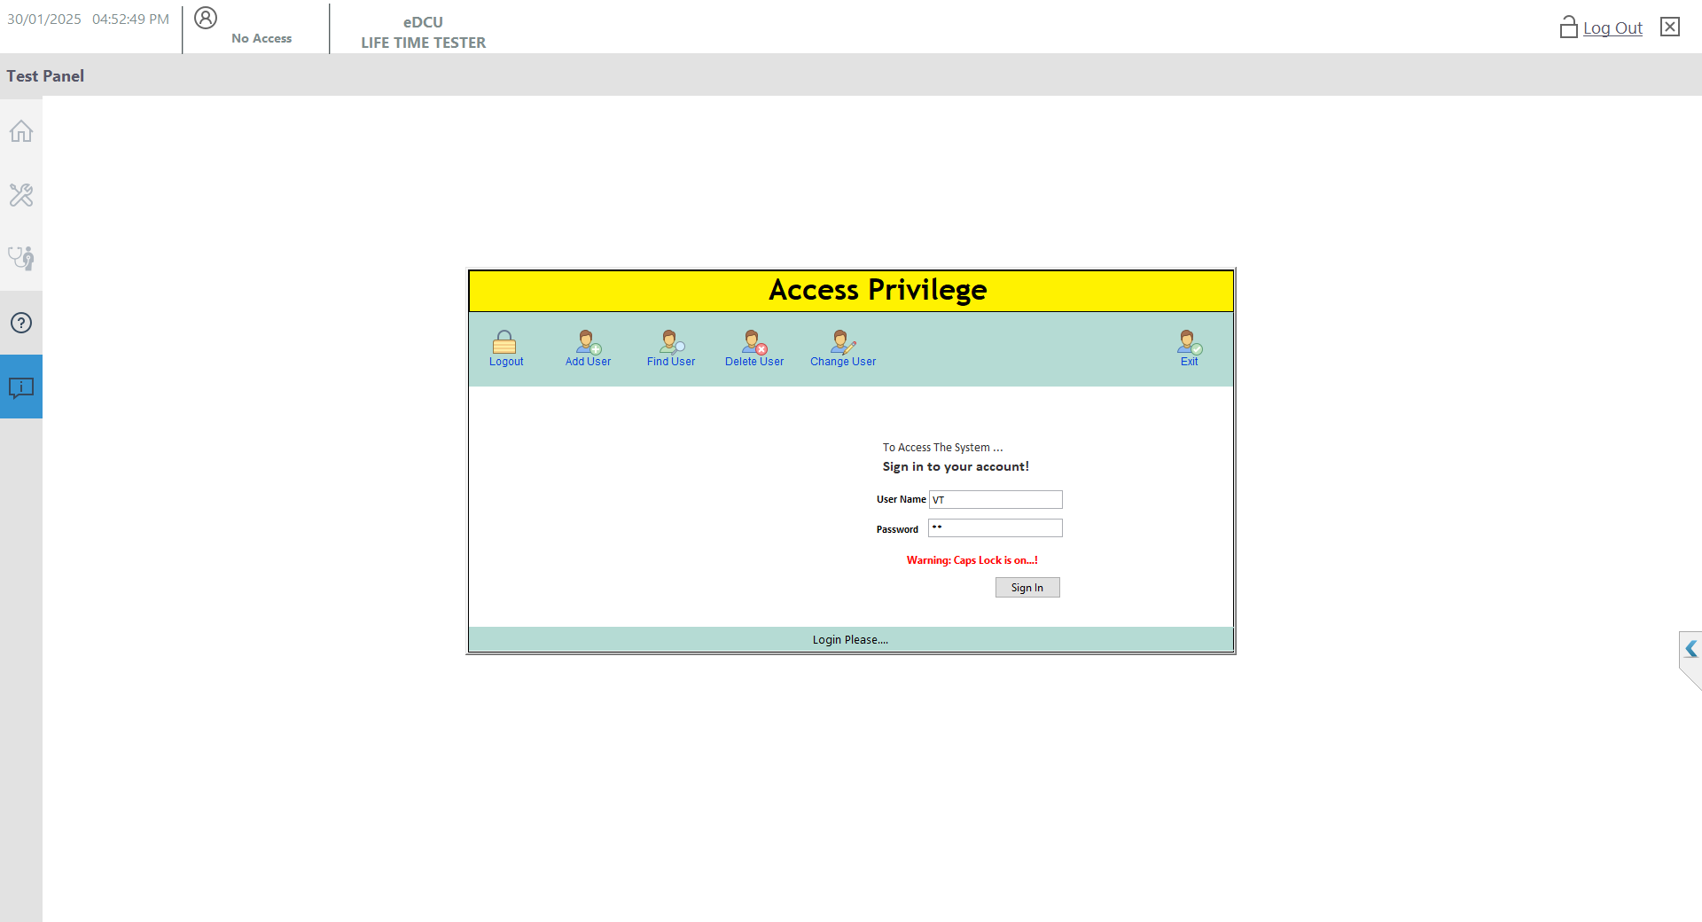

Figure 3: Main User Screen

Main Login:
Enter the “User Name” and “Password” Button from the Login screen below the user screen will appear. Click “Sign In”.

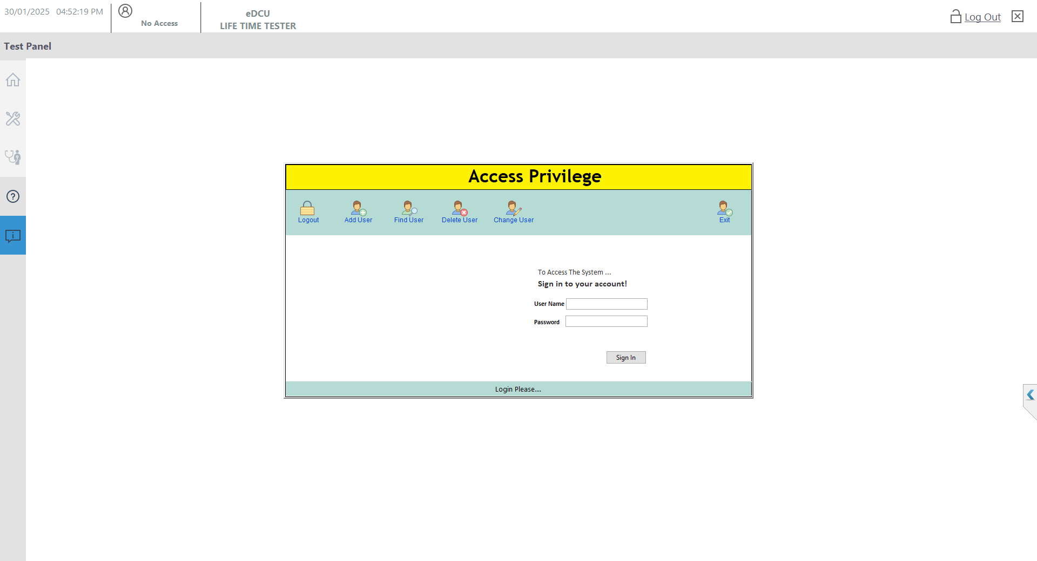
Enter the UserName and Password then Click “Sing In” button.
Figure 4: Login User Screen
Username: VT
Password: VT

Main Login Exit
Clicking the “Login OK” Button from the main screen below the user screen will appear. Click “OK”. 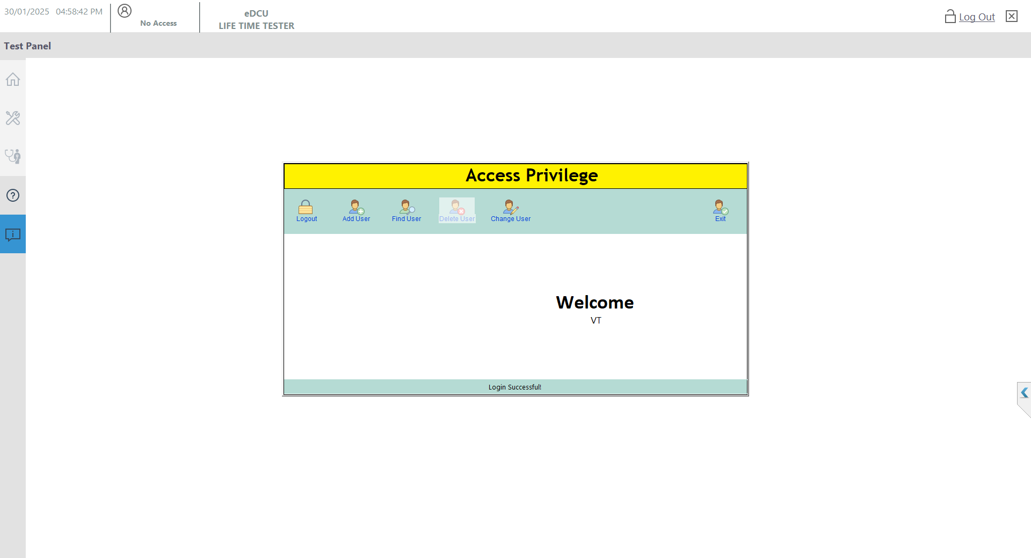
Enter the Login Successful Click “Exit” button.

Figure 5: Login Successful

Auto Mode:
Clicking the “Login Successful” Button from the Click ”Auto mode” screen below the user screen will appear. “Auto Mode GUI”.
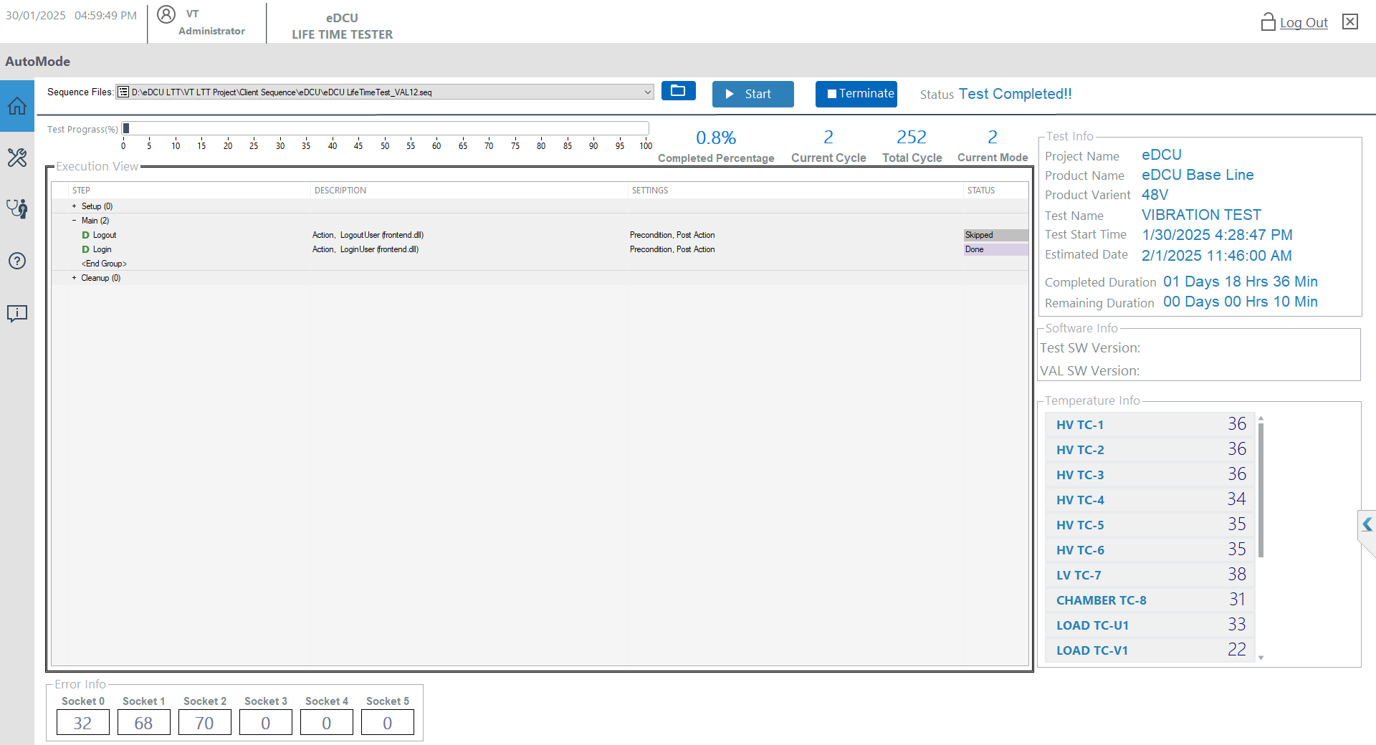
Enter the Login Successful Click “Exit” button.

Figure 6: Auto Mode GUI Screen

Test stand Login:
The “Auto Mode Successful” Button from the Click ”TestStand Login” screen below the user screen will appear. “Login”.

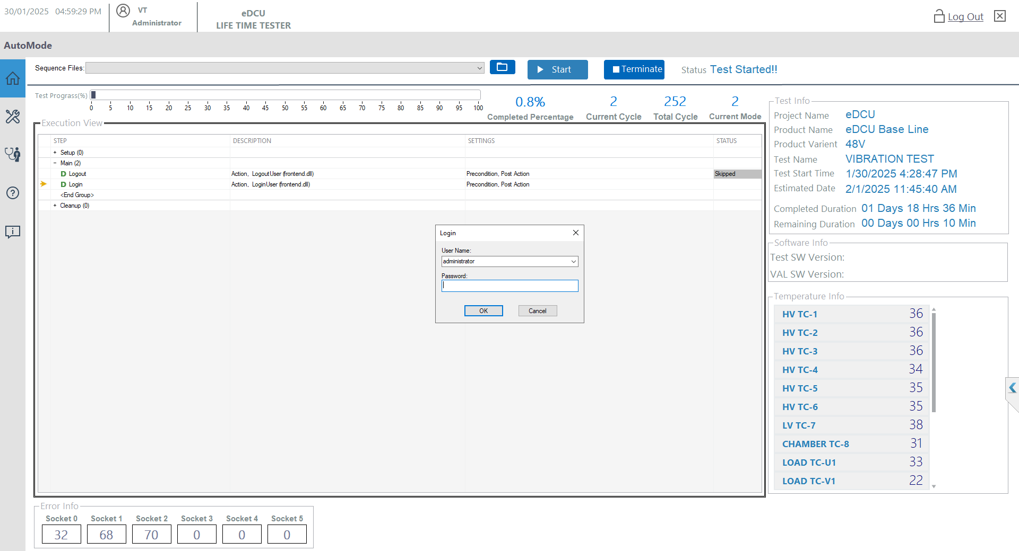
Click “OK” button.

Figure 7: Test stand Login User Screen

Sequence Selection:
Press the Open Sequence Files then Select the “eDCU LifeTimeTest.seq” Sequence from the path. screen below the user screen will appear. Click “OPEN”
Path: D:\eDCU LTT\VT LTT Project\Client Sequence\eDCU

Open “Sequence File”.

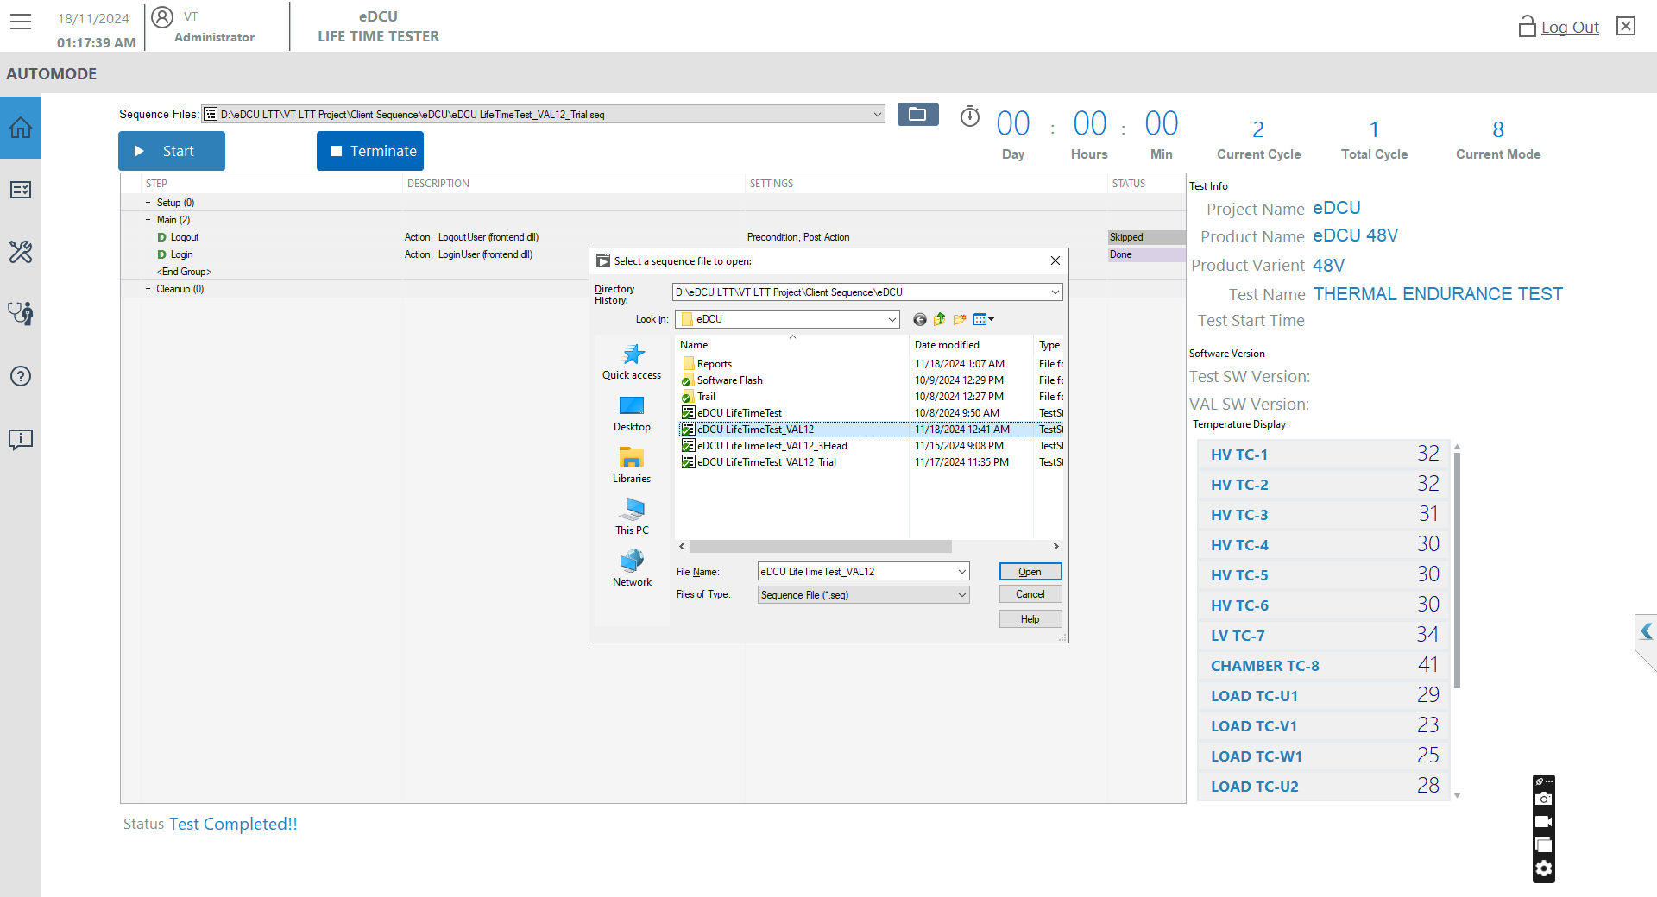
Final Click “OPEN”.
Select “eDCU LifeTimeTest”.

Figure 8: Sequence Selection

Test Windows:
Press the “Start” Sequence from the path. screen below the user screen will appear.
Path: D:\eDCU LTT\VT LTT Project\Client Sequence\eDCU\ eDCU LifeTimeTest.seq

Click Test Start Button “Start”.

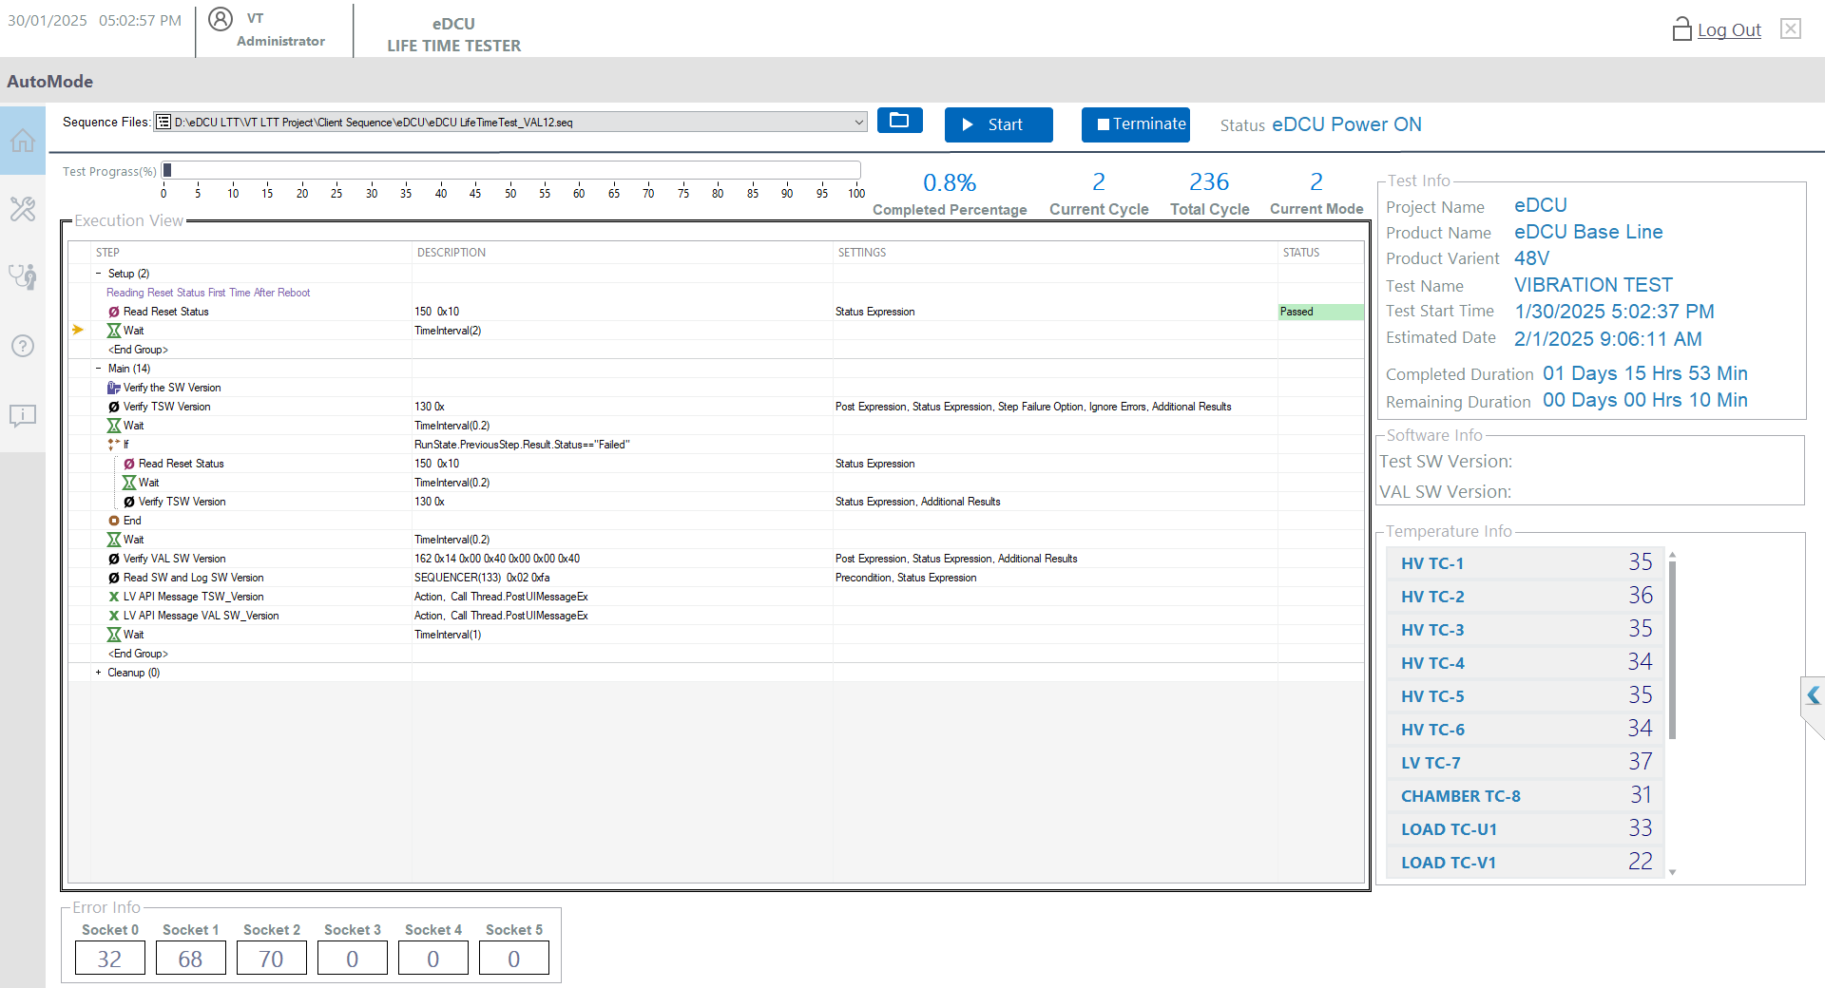

Figure 9: Start Test

Socket Entry Windows:
Press the “OK” IF “6”. The screen below the user screen will appear.

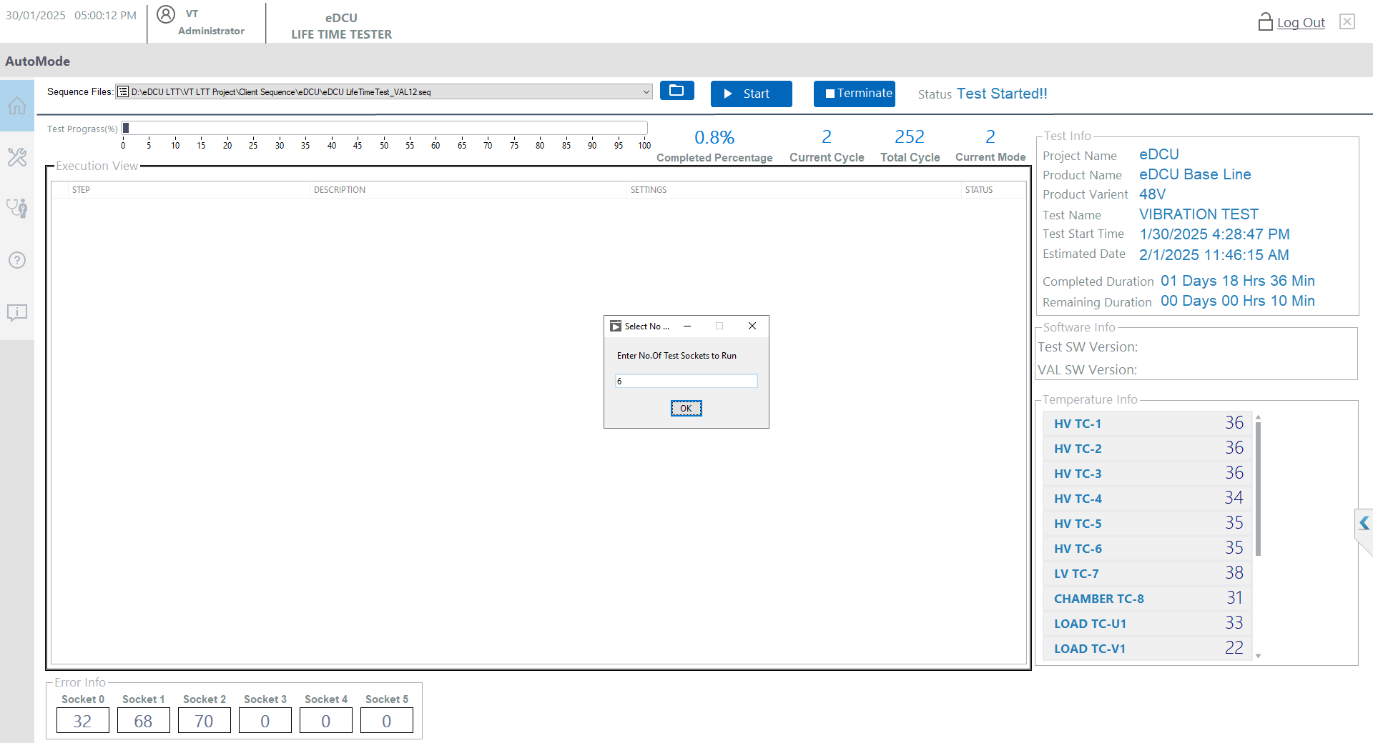
Click “OK”.

Figure 10: Socket Entry

UUT Info Entry Windows:
Enter the “Batch Number ” and “All Serial Number Enter”. The screen below the user screen will appear.
Batch No “Any Number”.
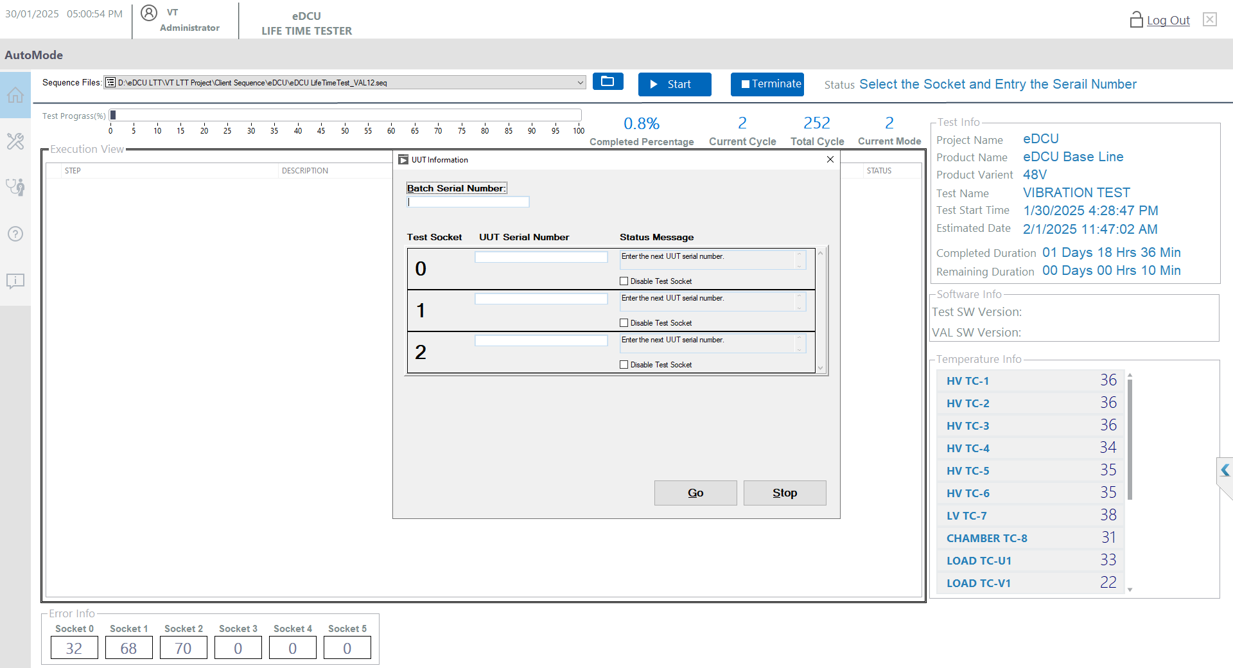
Enter all Serial No “Any Number”.

Figure 11: UUT Infomation

UUT Info Entry Scroll Windows:
Enter the “Batch Number” and “All Serial Number Enter” and Proceed to “GO” The screen below the user screen will appear.

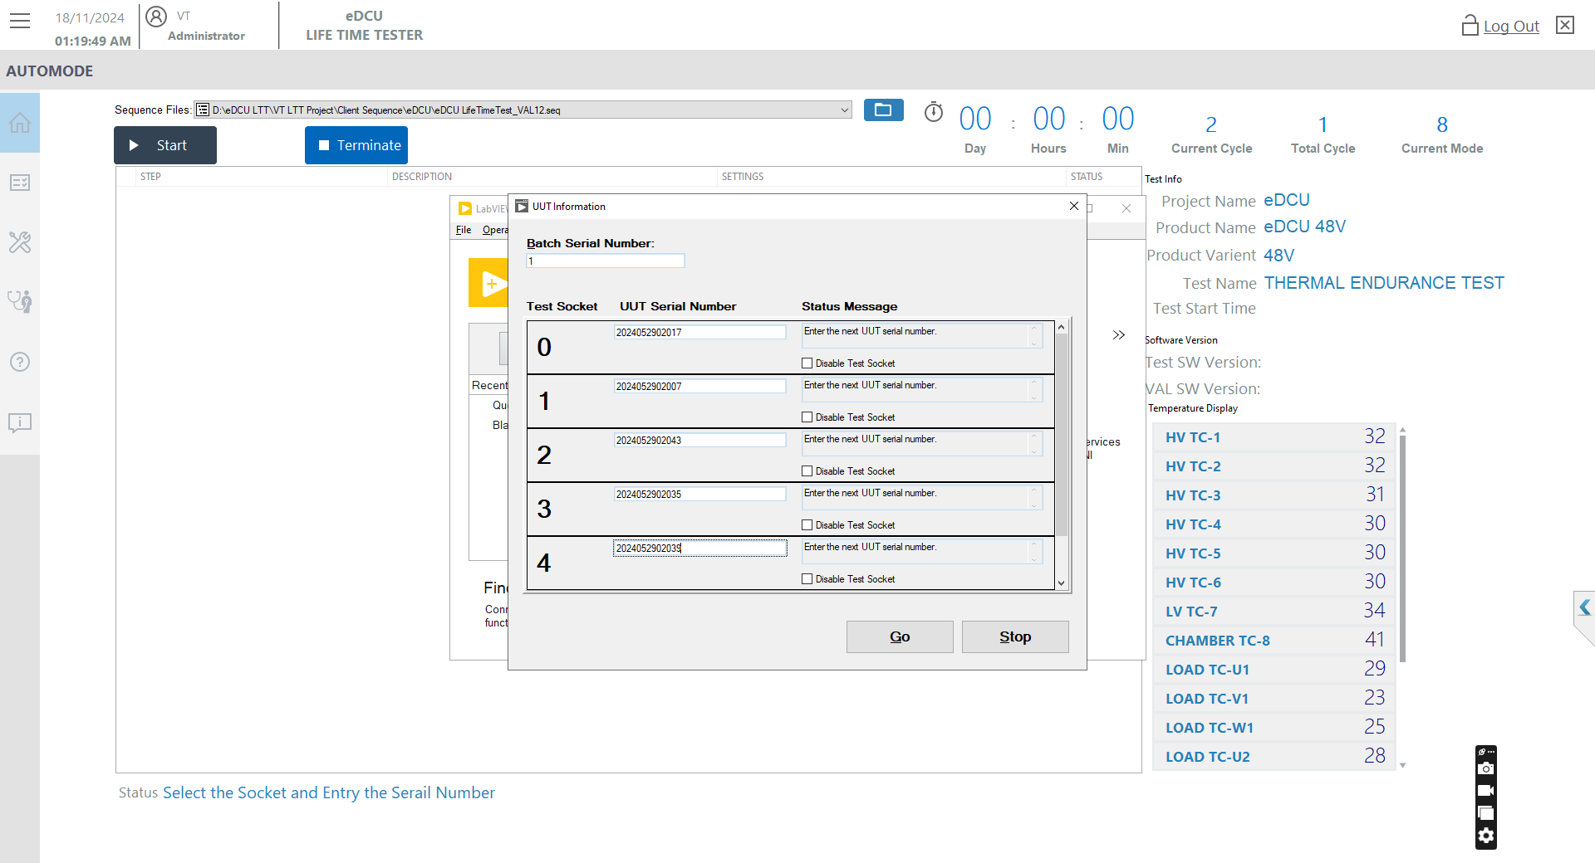
After all Entry only Click “GO”.

Figure 12: GO Test

Test Selection Windows:
Click the “Continuous Test”. The screen below the user screen will appear.

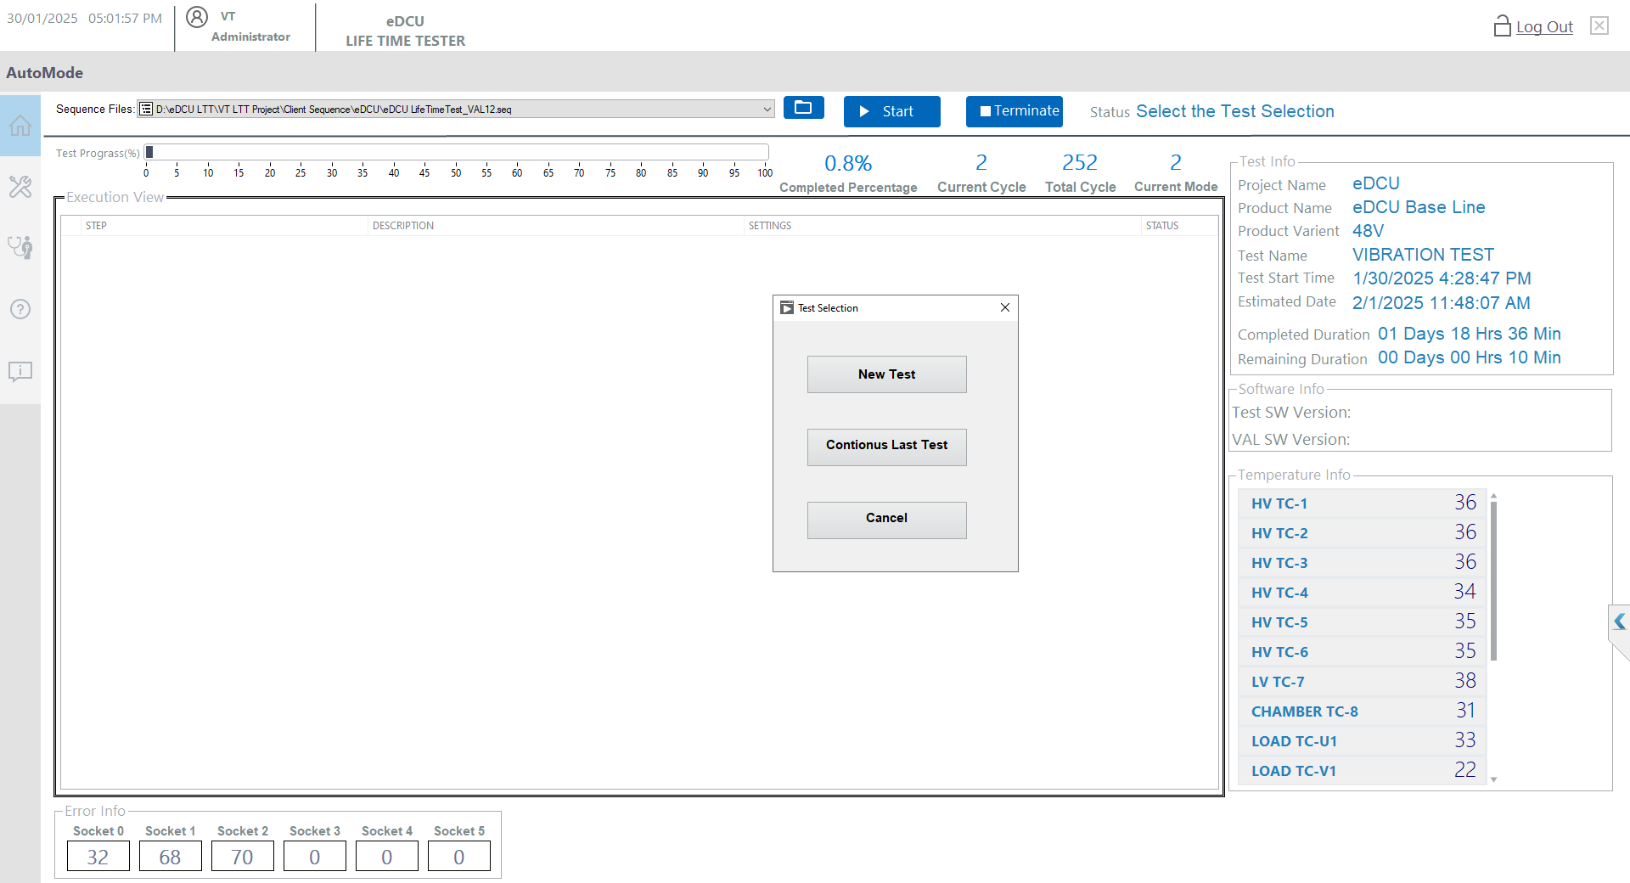
Click “continuous Test”.

Figure 13: Continuous Test Selection

Schema File Location:
Select the schema “File mention the name”. The screen below the user screen will appear.
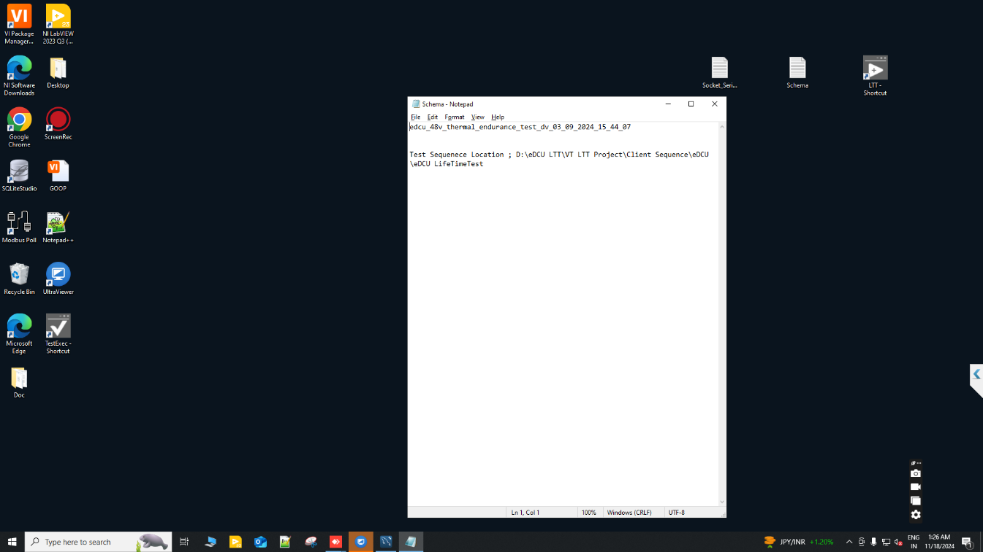
Mention File Location “Sequence File”.
Mention Schema Name “Select the Name”.

Figure 14: File Location

Schema Selection Windows:
Select the schema “File mention the name Schema Select Dropdown bar”. The screen below the user screen will appear.

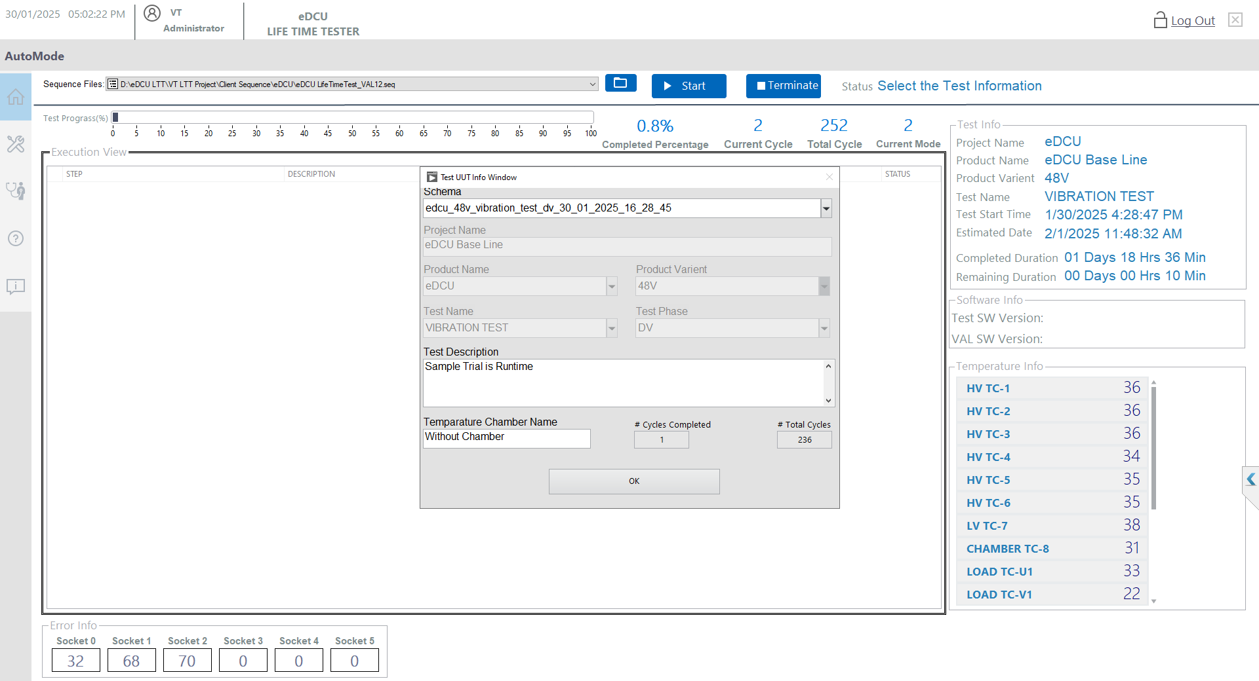
Test Info Entry
“OK”.
Enter the description
“Details Entry”.
Schema Name
“Select the Name”.

Figure 15: Test Info Schema Selection

Start the Chamber and Test Start Windows:
Select the schema “File mention the name”. Start the Chamber and when the chamber temperature targets is 50 deg set then click the OK Button. The screen below the user screen will appear.
This is applicable for thermal endurance test.
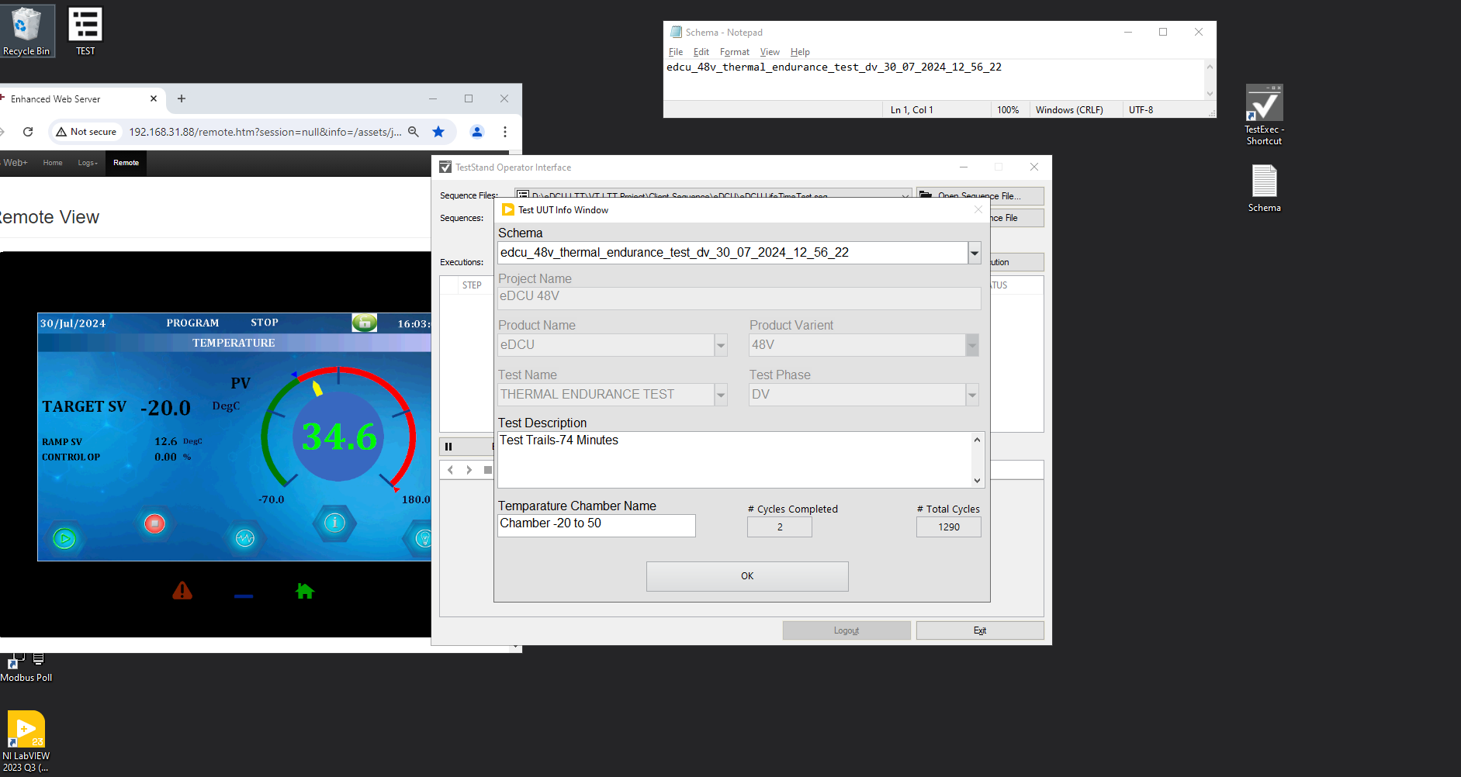
When Target SV “50 Deg” after the Test UUT Info Click “OK”

Mention Schema Name “Select the Name”.
Chamber Start after Target 50 Deg Set Click Button“OK”.

Figure 16: Stat and Click Ok

Running Windows of Monitor:
Check the Display the Status Update “Running Display”. Any message showing please inform the concern person. screen below the user screen will appear.
Test Prograss
Test Info and SW Info
Cycle and Mode Information


Execution View
Temperature Information
Fail Count Based Socket

Terminate Test Procedure:
Terminate the test Double Click Terminate the button and Terminate the test. Any message showing please inform the concern person. screen below the user screen will appear.
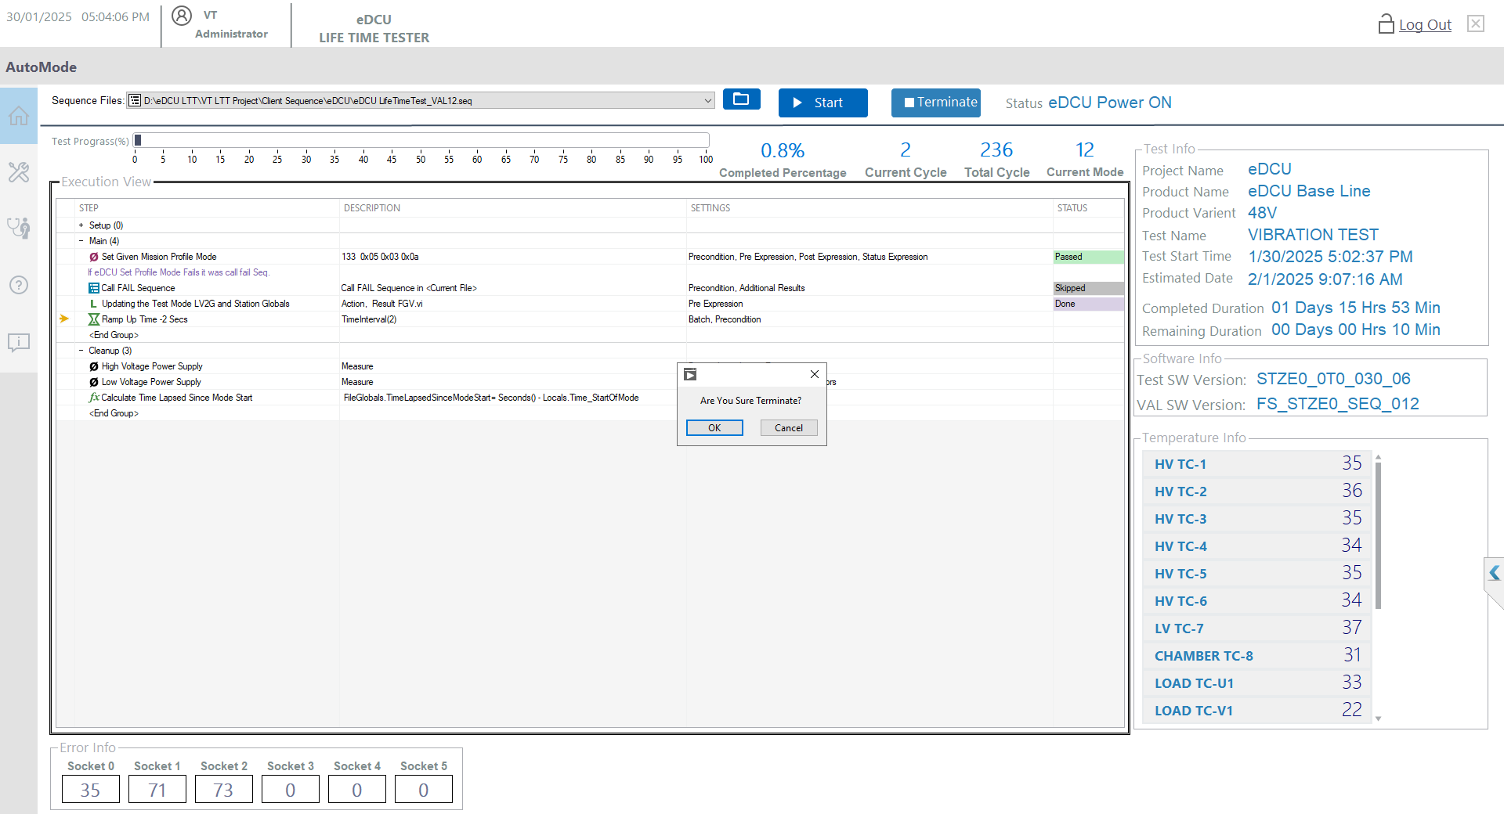
Wait 10 Secs then Final Click the “EXIT”
Double Click the “Terminate All”. Please Inform and Need to Terminate Test
Click the “YES or NO”

Error Pop-UP Test Procedure:
If any error popup like come so Select the Run Cleanup and tick the Don’t show again batch execution then click the OK. screen below the user screen will appear.

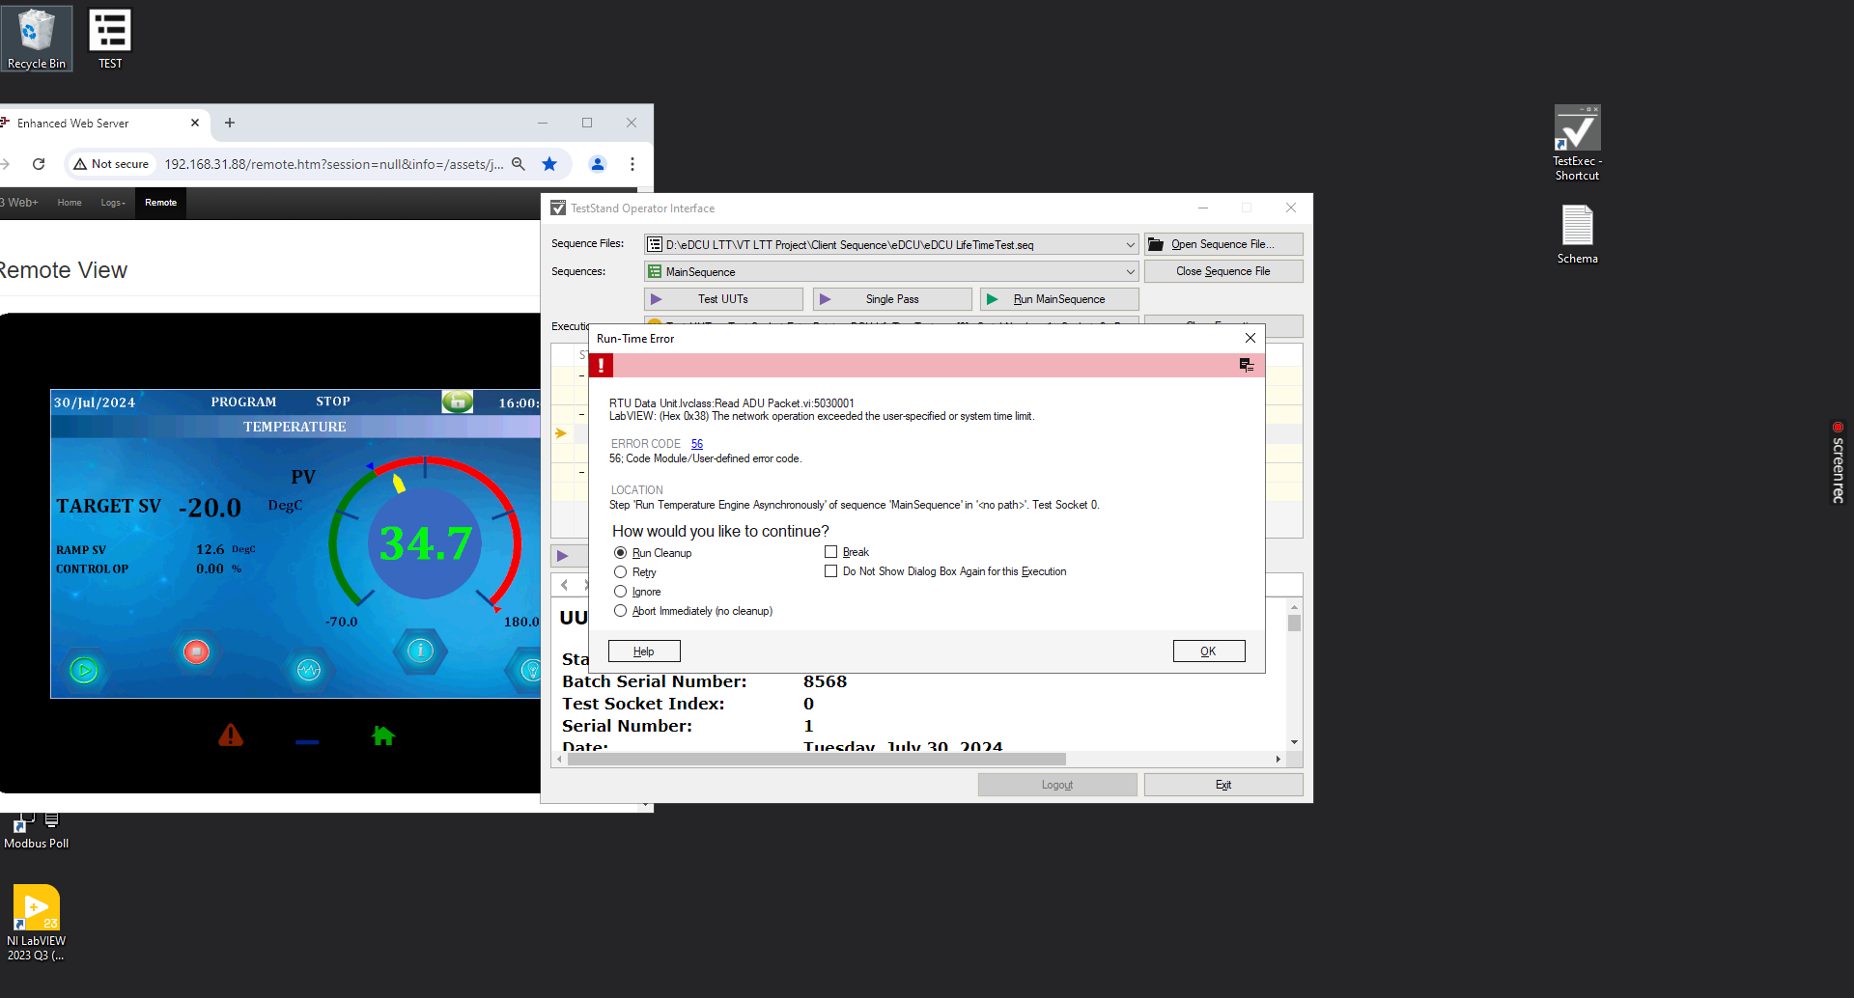
Tick the “Don’t Show again batch”
Click the “Run Cleanup All”
Final Click the “OK”

Exit Application:
If Exit the application Click the Exit button flowing the procedure. screen below the user screen will appear.

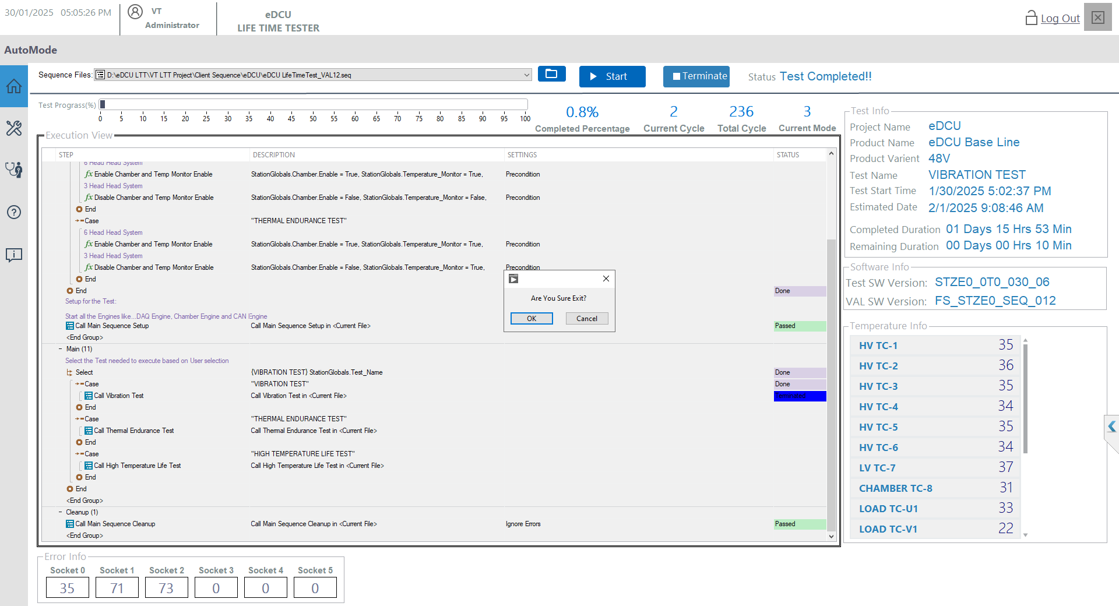
Click the “Exit”
Final Click the “OK or Cancel”

